Name: ___________________________________________________ Date:

50

= %


Year 10 Mathematics

Test 3 - 2015

Topics: Linear and Quadratics
Total Time: 55 minutes Weighting: 5% of the year.
This test comprises of TWO sections. The first section is calculator free where no calculators of any kind are to be used. The second section is calculator assumed where calculator may be used. All questions must be answered in both sections. Answers should be rounded to 2 decimal places unless specified. All working should be shown in the space provided. Solutions without working may not be awarded full marks. Please take the marks for each question into account when answering the question.
SECTION 1: CALCULATOR FREE
Time: 20 minutes Equipment Allowed: Formula sheet
Marks for Section 1: 25marks

1. ( 10marks: 2,2,2,2,2)

Solve: a. –6 + 3b = –9. b. + 2 =

c. 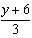 + 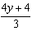 = . d. $x^{2}-5x-14=0$

e. $5=21-7(1-x)$

2. (4 marks: 2, 2)

Find the gradient of each of the following lines through the given points.

- (-3, -2) and (3, 2) b. (2, 7) and (5, 9)

3. (3 marks)
Is the line with equation $y=3x-10$ parallel or perpendicular to the line with
equation $6y+2x+12=0$? Show your working to justify your answer.

4. (8marks:1,3,4 )
Given the graph of y = x² + 2x – 8, determine the coordinates of its

(i) y- intercept

(ii) x-intercept

(iii) turning point, stating whether it is a minimum or a maximum

Name: ___________________________________________________ Date: _________
SECTION 2: CALCULATOR ASSUMED
Time: 40 minutes Equipment Allowed: Formula sheet, 1 page of notes (A4), calculators
Marks for Section 2: 25marks

5. (5 marks)

Solve the following simultaneous equations graphically.
x+ 2y = 4
y= x – 1

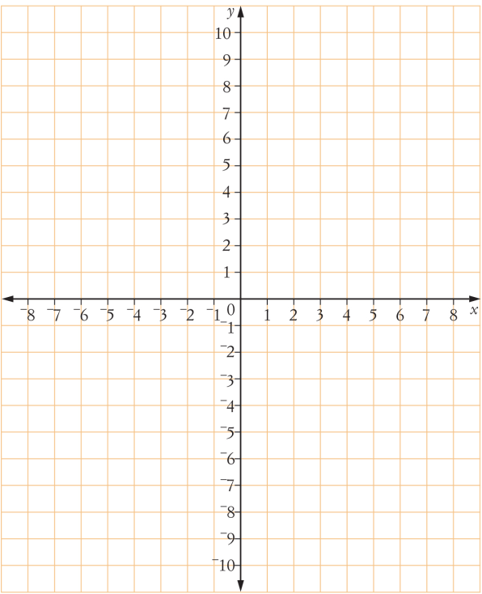

6. (4 marks)
Solve the following simultaneous linear equations by either substitution or elimination.

x + 3y = –9
2x + 2y = –6

7. (4 marks:2,2)
Find the (i) length (ii) midpoint
of the line joining the points (–3, –4) and (2, 1).
Give your answer to two decimal places if required.

8. (9 marks:4,2,21)
Complete the table below and use it to draw the graph y = –x² + 2x + 8, for -3≤ x ≤ 4

x
y



From the graph, find
(i) the coordinates of the turning point, stating whether it is a maximum or a minimum

(ii) the equation of the line of symmetry

9. ( 3 marks)
Solve the equation x² – 24x + 130 = 0 by using the quadratic formula.
Give your answer to 2 decimal places if required.

